Insert School Logo

Semester One Examination 2020

Question/Answer Booklet

MATHEMATICS SPECIALIST
UNIT 3

Section Two:
Calculator-assumed

Student Name: _____________________________________

Teacher’s Name: _____________________________________

Time allowed for this section
Reading time before commencing work: ten minutes
Working time for paper: one hundred minutes

Material required/recommended for this section

To be provided by the supervisor
This Question/Answer booklet
Formula Sheet (retained from Section One)

To be provided by the candidate
Standard items: pens(blue/black preferred), pencils(including coloured), sharpener, correction tape/fluid, erasers, ruler, highlighters

Special Items: drawing instruments, templates, notes on two unfolded sheets of A4 paper, and up to three calculators approved for use in the WACE examinations.

Important note to candidates
No other items may be taken into the examination room. It is your responsibility to ensure that you do not have any unauthorised notes or other items of a non-personal nature in the examination room. If you have any unauthorised material with you, hand it to the supervisor before reading any further.

Structure of this paper

 | Number of questions available | Number of questions to be attempted | Suggested working time (minutes) | Marks available | Weighting
Section One  Calculator—free | 7 | 7 | 50 minutes | 53 | 35%
Section Two  Calculator—assumed | 10 | 10 | 100 minutes | 97 | 65%
 |  |  |  | 150 | 100%

Instructions to candidates

- The rules for the conduct of Western Australian external examinations are detailed in the Year 12 Information Handbook 2020. Sitting this examination implies that you agree to abide by these rules.

- Answer the questions according to the following instructions.

Section Two: Write answers in this Question/Answer Booklet. Answer all questions.

Show all your working clearly. Your working should be in sufficient detail to allow your
answers to be checked readily and for marks to be awarded for reasoning. Incorrect
answers given without supporting reasoning cannot be allocated any marks. For any
question or part question worth more than two marks, valid working or justification is required to receive full marks. If you repeat an answer to any question, ensure that you cancel the answer you do not wish to have marked.

It is recommended that you do not use pencil, except in diagrams.

- You must be careful to confine your responses to the specific questions asked and to follow any instructions that are specific to a particular question.

- Spare pages are included at the end of this booklet. They can be used for planning your responses and/or as additional space if required to continue an answer.
- Planning: If you use the spare pages for planning, indicate this clearly at the top of the page.
- Continuing an answer: If you need to use the space to continue an answer, indicate in the original answer space where the answer is continued, i.e. give the page number. Fill in the number of the question that you are continuing to answer at the top of the page.

- The Formula Sheet is not handed in with your Question/Answer Booklet.

Section Two: Calculator–assumed 97 marks

This section has ten (10) questions. Attempt all questions.
Write your answers in the spaces provided.

Working time: 100 minutes

Question 8 (5 marks)

The function $f\left(x\right)=ax+b+\frac{k}{\left(x+c\right)\left(x+d\right)}$ is shown below, where $a, b, c, d, k∈R$.

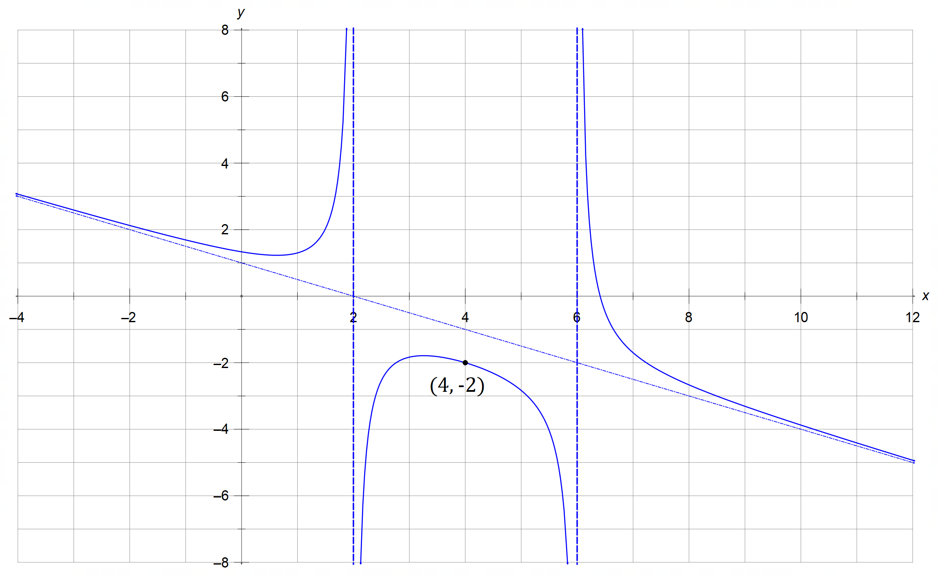

State the value of the constants $a, b, c, d$ and $k$. (5 marks)

Question 9 (10 marks)

Triangle ABC in space has vertices with position vectors $\vec{OA}=i-2j-k$, $\vec{OB}=-2i+j+2k$
and $\vec{OC}=2i+3j+5k$.

(a) Find the size ofBAC correct to the nearest degree. (3 marks)

(b) Find the vector equation $r=p+λd_{1}+μd_{2}$ of the plane that contains triangle ABC. (1 mark)

(c) The line L has equation $r=α\left(\begin{matrix}m \\ 7 \\ n\end{matrix}\right)$ and it is perpendicular to the plane found in (b).

(i) Show that $m=1$ and $n=-6$. (2 marks)

(Question 9 – Continued) (Continued)

(ii) Find the point of intersection between the line L and the plane.
(3 marks)

(d) Determine the shortest distance of the plane from the origin. (1 mark)

Question 10 (10 marks)

(a) On the Argand planes provided below, sketch the locus of the complex number $z=a+bi$ that
satisfies the given conditions.

(i) $\left|z+2i\right|=\frac{3}{2}$ (3 marks)

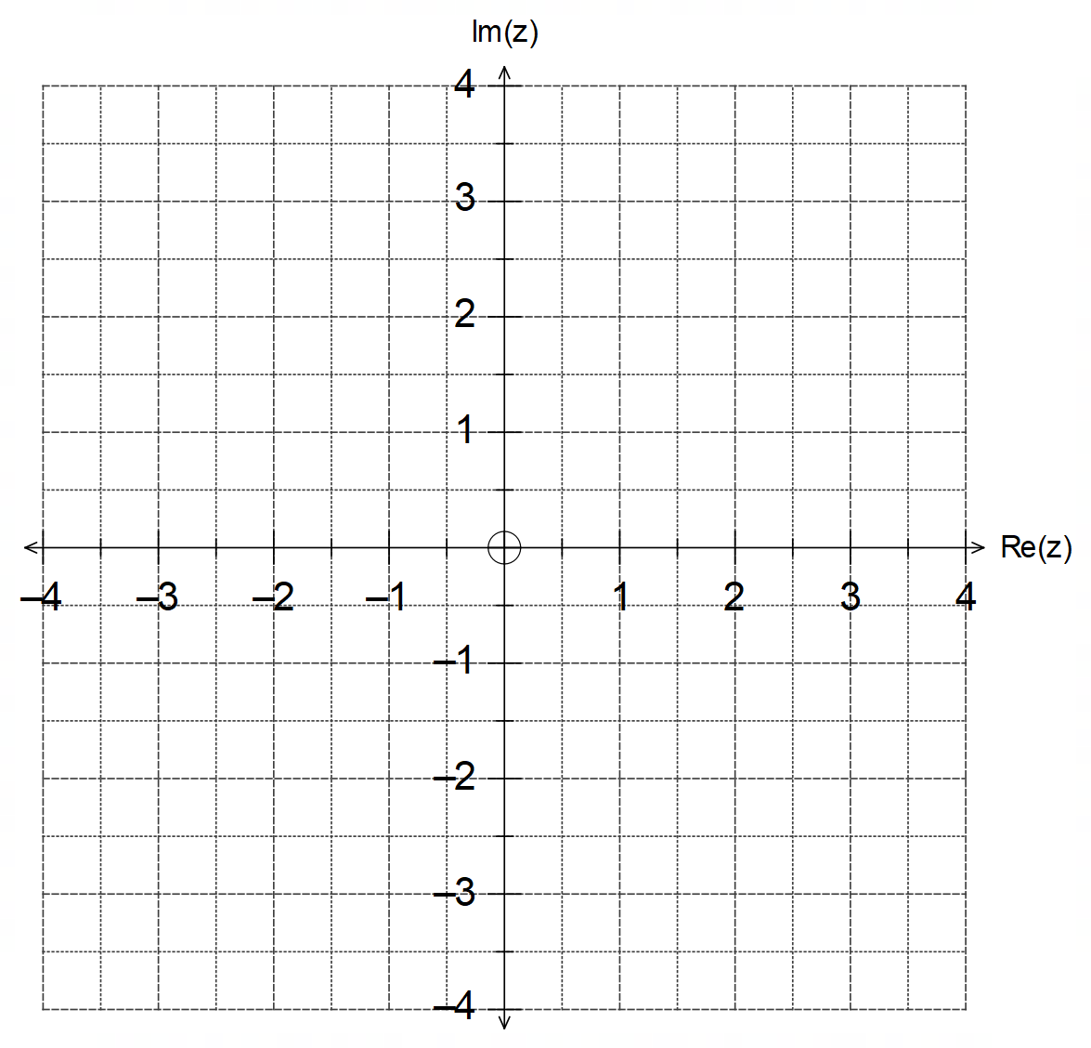

(ii) $\left|z-3i\right|=\left|z-4+3i\right|$ (3 marks)

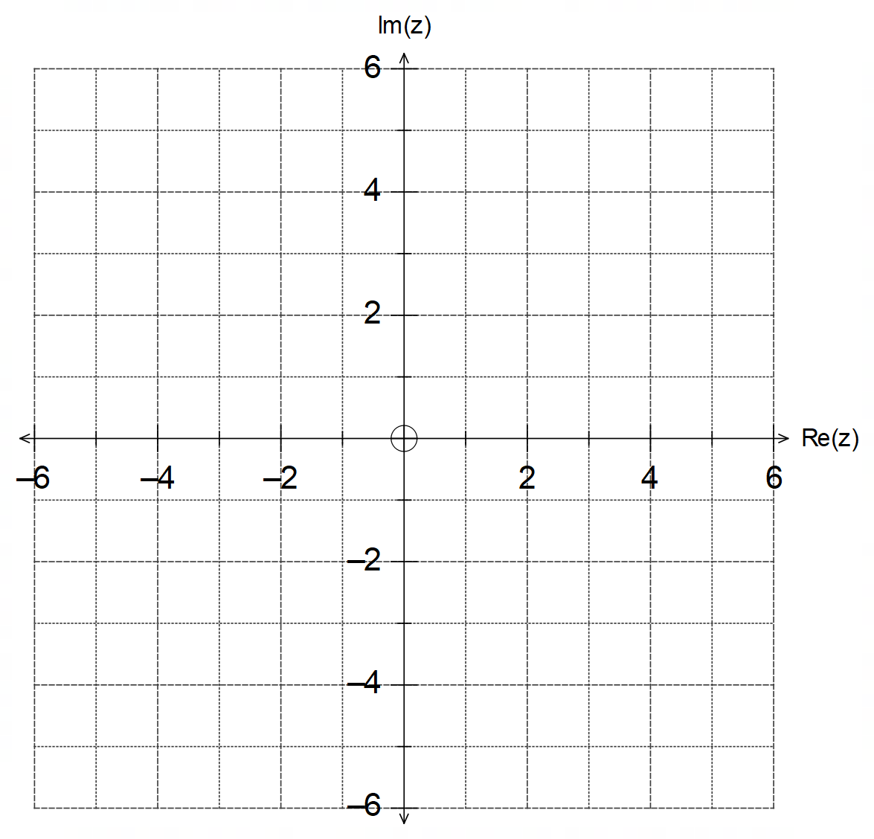

(Question 10 – Continued)

(b) For the locus of $\left|z+2i\right|=\frac{3}{2}$ in part (a), state the exact maximum value of the modulus $\left|w\right|$
and the exact maximum value of the argument $arg⁡(w)$ for $w=z-i$, where $\left|w\right|>0$ and $-π<\arg\left(w\right)≤π$.
(4 marks)

Question 11 (17 marks)

The position of a particle in 2D space is given by $r\left(t\right)=2\cos\left(t\right)i-2\cos\left(2t\right)j$, where $\left|r\left(t\right)\right|$is
given in metres and $t$ in minutes since the motion began.

(a) Sketch the path traced by the particle on the axes provided below. (3 marks)

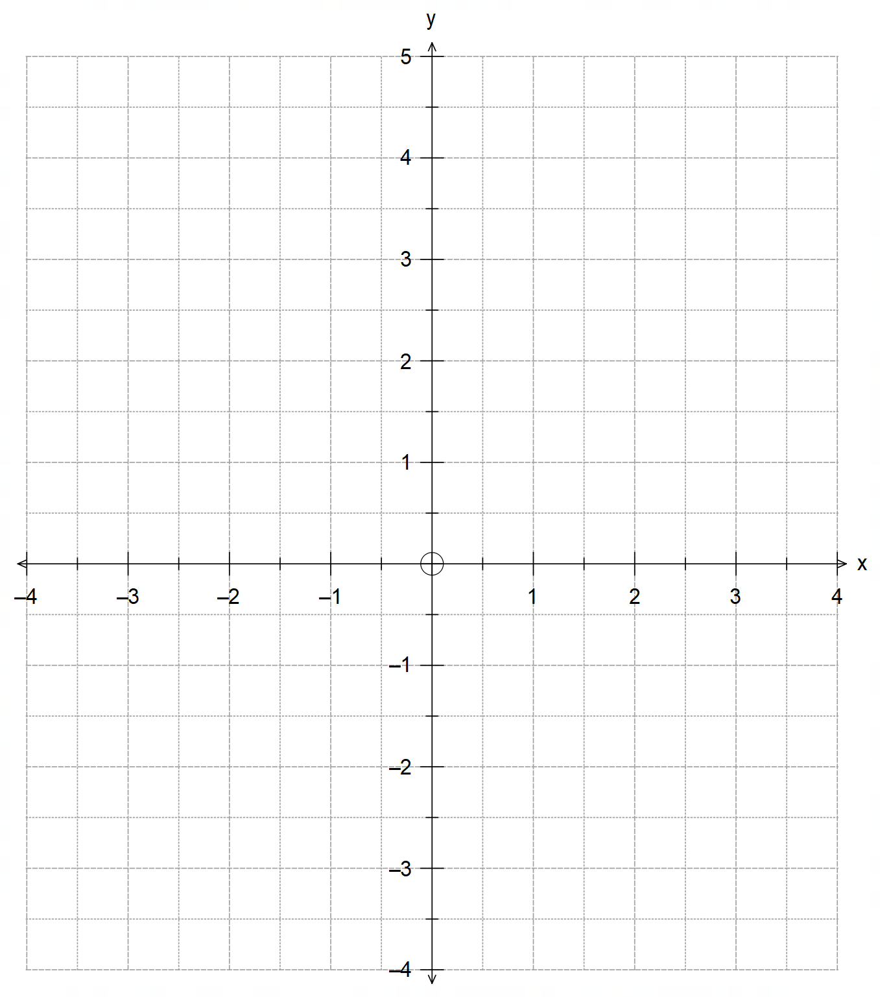

(b) State the time it takes for the particle to complete one full cycle of motion. (1 mark)

(Question 11 – Continued)

(c) Determine the position and velocity vectors of the particle at the instant where $x=1$
for the first time. Clearly draw these vectors on the same diagram in part (a). (6 marks)

(d) Find the magnitude of acceleration of the particle at time $t=\frac{π}{6}$. (2 marks)

(Question 11 – Continued)

(e) Show that the speed of the particle is given by $\left|\dot{r}\right|=2\sin{t}\sqrt{1+16\cos^{2}{t}}$. (2 marks)

(f) State the Cartesian equation of the path traced by the particle. (3 marks)

Question 12 (6 marks)

The grid below shows the graph of $\left|x\right|+\left|y\right|=4$ for its natural domain.
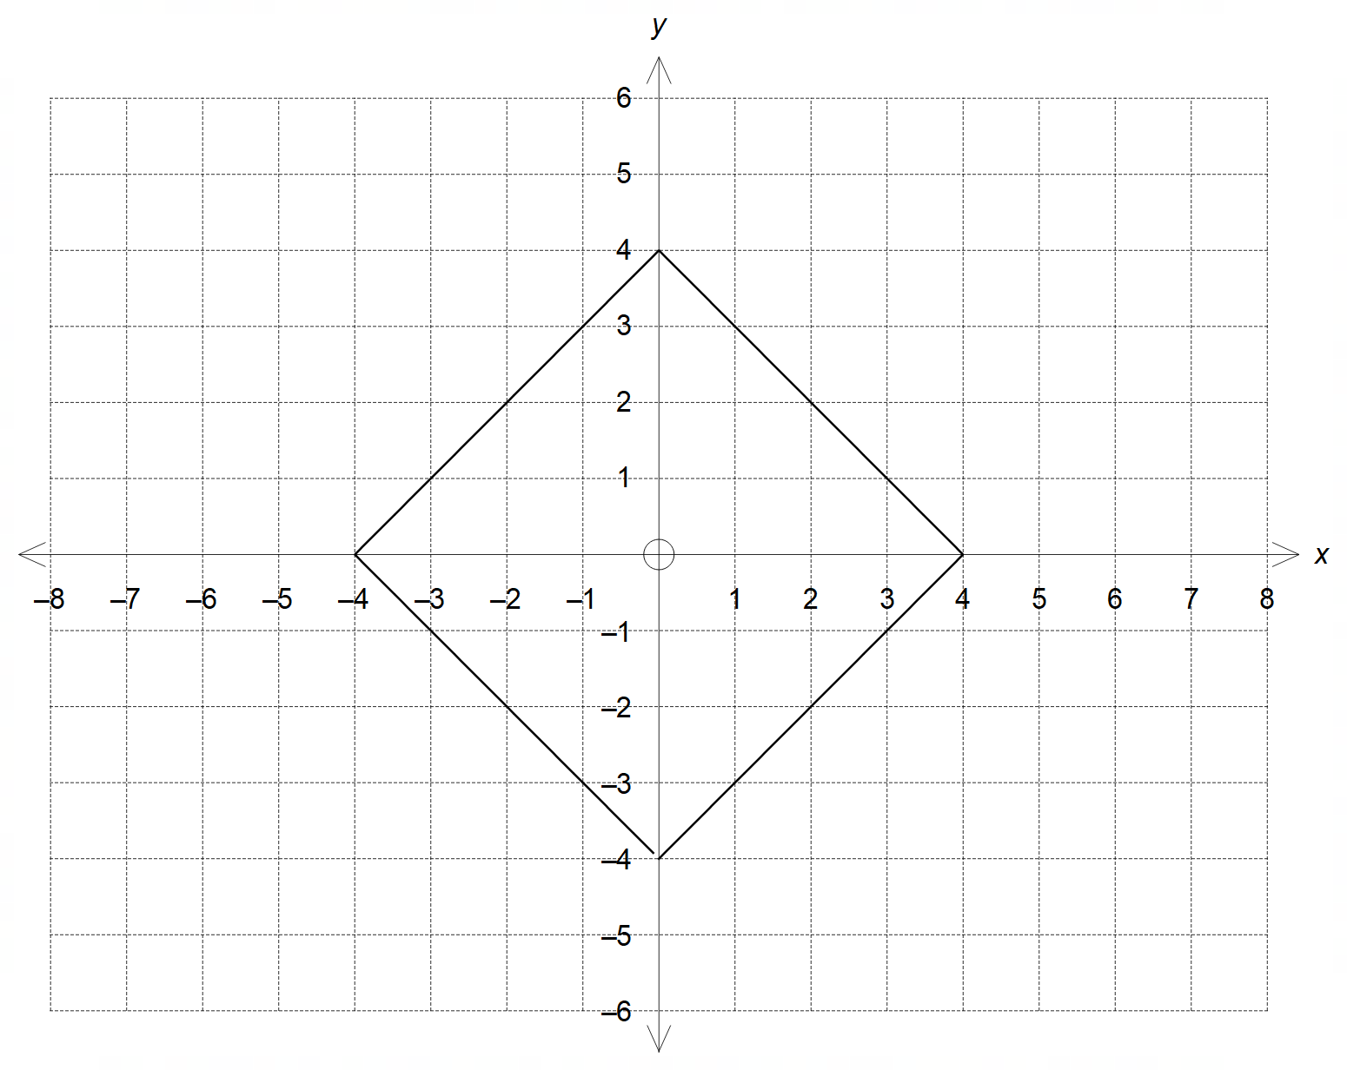

(a) On the same axes sketch the graph of $\left|y\right|+\left|x-4\right|=4$ for its natural domain. (2 marks)

(b) The graph of $x^{2}+y^{2}=k$ intersects the graph of $\left|x\right|+\left|y\right|=4$ four times.
State the value(s) of the constant $k$. (2 marks)

(c) State the condition(s) on the positive constants $m$ and $n$ so that the graph of
$y=m\left|x\right|-n$ intersects the graph of $\left|x\right|+\left|y\right|=4$ exactly three times. (2 marks)

Question 13 (13 marks)

(a) The diagram below shows one of the solutions to the equation $z^{5}=a+bi$.
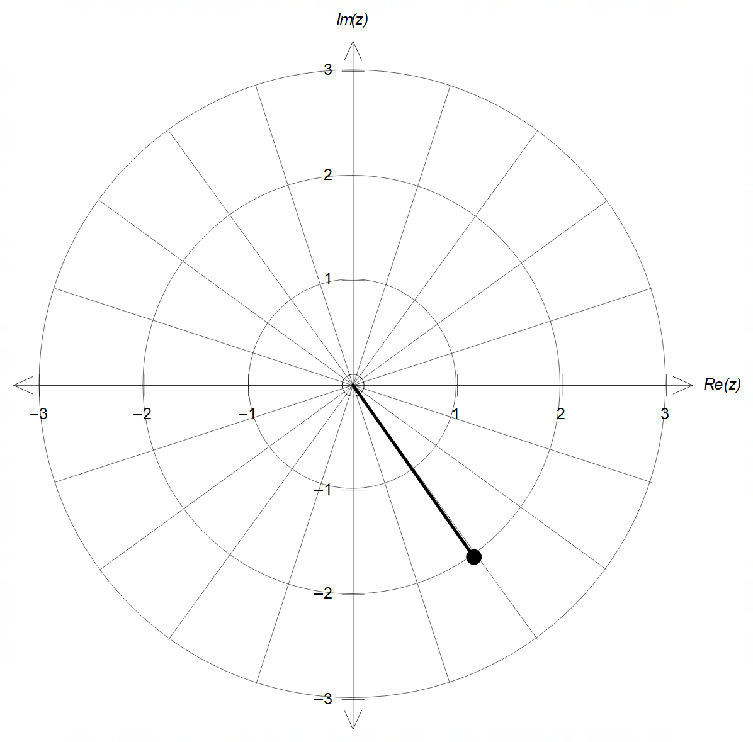

Determine the value of $a$ and $b$, and hence state the other solutions to the equation $z^{5}=a+bi$
in polar format. On the same diagram sketch the other solutions found.
(7 marks)

(Question 13 – Continued)

(b) The complex numbers $v$ and $w$ are shown on the polar grid below.

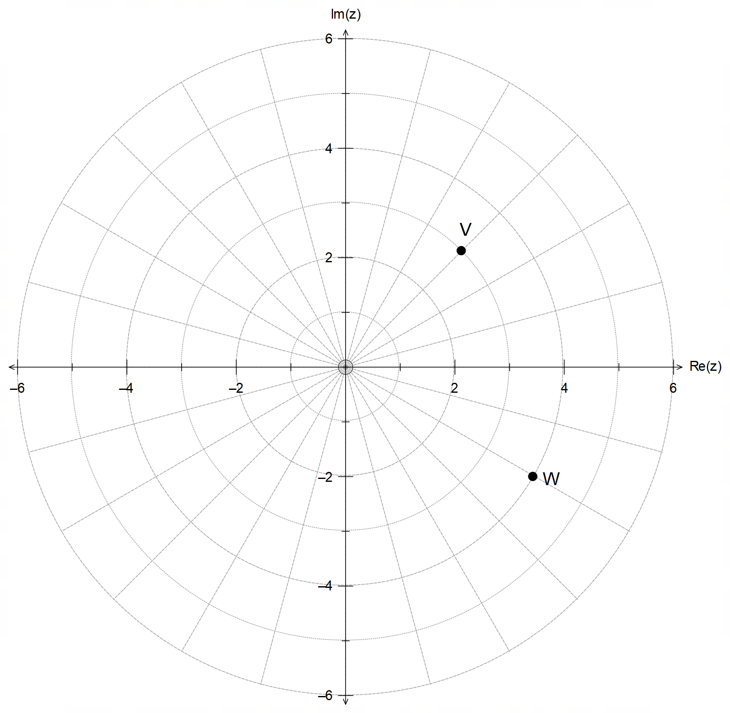

On the same grid above, mark the position of each of the following:

(i) $\frac{-v}{i}$ (2 marks)

(ii) $w-\overline{w}$ (2 marks)

(iii) $v×w^{0.5}$ (2 marks)

Question 14 (11 marks)

At $t=0$, particle $A$ is located at $3i-2j+6k$ metres from O and it is moving at $4i+3j-2k$ m/s, while particle $B$ is located at $24i-2j+36k$ metres from O.
At $t=3$ seconds, particle $B$ begins to move with a velocity of $\left(\begin{matrix}x \\ y \\ z\end{matrix}\right)$ m/s.

(a) Determine the speed of particle $B$ if they collide $9$ seconds after particle $B$ begins to move.

(4 marks)

It is now required that particle $B$ moves with a constant velocity from $t=3$.

(b) State the equation required for collision to occur.
(2 marks)

(Question 14 – Continued)

(c) Hence, or otherwise, determine the time and position of collision if $B$ moves at $6 m/s$.

(5 marks)

Question 15 (12 marks)

An involution is a function that meets the condition $ff\left(x\right)=f^{2}\left(x\right)=x$.

Consider the function $g\left(x\right)=a^{2}+$ $\frac{1}{x - a^{2}}=\frac{a^{2}x + b}{x-a^{2}}$ for some constant $a,b∈R$.

(a) Show that $g\left(x\right)$ is an involution, and state its domain and range in terms of $a$. (3 marks)

(b) Sketch the graph of $g\left(x\right)$ on the axes below, clearly indicating all of its relevant
features in terms of the constant $a$. (3 marks)

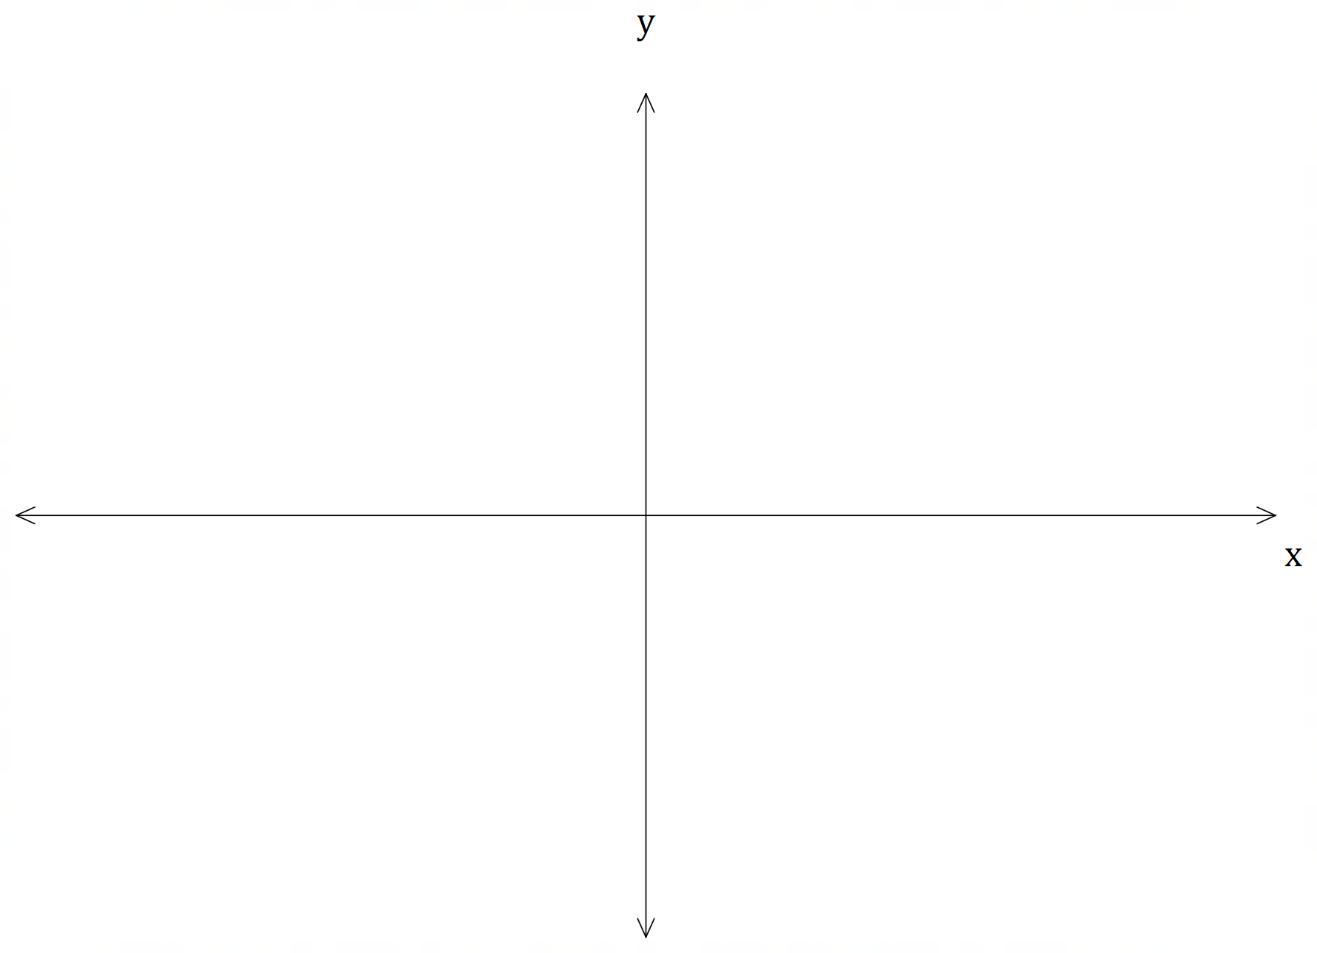

(Question 15 – Continued)

(c) The function $h\left(x\right)=\frac{2x + k}{x-2}$ is defined for some real constant $k$.

(i) Find the value(s) of the constant $k$ that would make $h\left(x\right)$ an involution. (2 marks)

(ii) Given that $h\left(x\right)$ is an involution, describe the relationship between $h\left(x\right)$
and its inverse, $h^{-1}\left(x\right)$, in terms of their domain and range, graphs and
their graphical features. (4 marks)

Question 16 (7 marks)

Consider the complex number $z=\operatorname{cis}{θ}$ and the expansion of $z^{n}={\left(\cos{θ}+i\sin{θ}\right)}^{n}$.

(a) Use De Moivre’s theorem to express $\sin\left(6θ\right)$ in terms of $\sin\left(2θ\right)$. (4 marks)

(b) Use your result in (a) to solve exactly the equation $3x-4x^{3}=1$. (3 marks)

Question 17 (6 marks)

Given$f\left(x\right)=2x-1$ and $g\left(x\right)=\frac{x}{2}-4$, find ${\left(f∘g\right)}^{-1}\left(x\right), \left(f^{-1}∘g^{-1}\right)\left(x\right)$ and $\left(g^{-1}∘f^{-1}\right)\left(x\right)$.
Hence, make a conjecture about the inverse of a composition of two functions in terms of their respective inverses.

(6 marks)

END OF QUESTIONS
Additional working space

Question number(s): ……………………

Additional working space

Question number(s): ……………………

Additional working space

Question number(s): ……………………

Additional working space

Question number(s): ……………………

